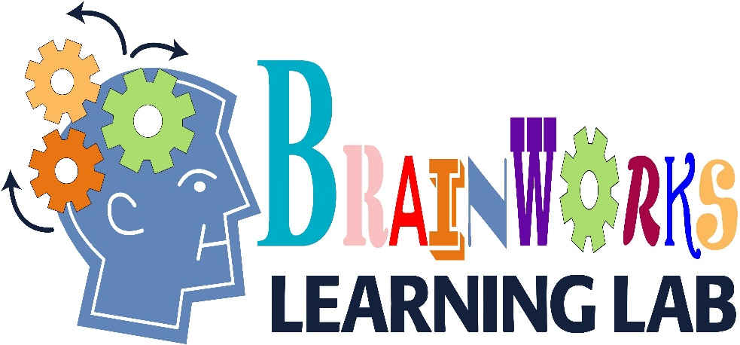 Draft for 2018

**NOTICE:** All camps require a $25 non-refundable deposit and will be filled on a first come first serve basis. This deposit will be applied to the cost of the camp. Trading camps will be permitted based on availability ONLY.

“**Art Camp**” Ages 8 & up- Students will design and bind their own sketchbook, complete a canvas painting inspired by the work of Alexandra Nechita, journey to the High Museum, and complete a piece inspired by their museum visit. Students will end the week will a small art exhibition for family and friends. Cost: $135 includes field trip to The High Museum of Art.

**July 2018**

**“Creative Writing Camp”** Ages 8-11

In order to help prepare students for the writing for Georgia Milestones, this camp will offer a fun way to work on writing for all genres. Cost $100

**“STEAM”** Ages 8 & up- Students will learn more about science, technology, engineering, art and math. Cost $120 which includes field trip to Dauset Trails

“**LEGO Camp**” Ages 5 & up- This camp is structured to promote creative building. Campers, both novice and the long--time builders are challenged by daily themes and mini-challenges. Cost: $135 includes field trip to LEGOLAND.

**“Old School Games”-** Ages 5 & up- Students will explore forgotten games from past generations such as marbles, pick up stix, jacks, and various board and outdoor games. Cost: $110

**“Puppet Workshop”** Ages 5 & up- Students will create their own puppets, learn the art of acting, and become the voice of the character. We will be taking a field trip to Center of Puppetry Arts for a show and workshop. Cost $130 includes field trip

**July 31-August 4**

**“Back to School Bash”** Ages 5 & up- This week we will be offering an extended day camp (7:30-4:30) with a variety of off-campus activities. Swimming, bowling, skating, movies and more will entertain students during their last week of summer. Students will need to bring a sack lunch each day. Cost $210 which includes trips.

**June 2018**

9:00-12:00 Daily

“**LEGO Camp**” Ages 5 & up- This camp is structured to promote creative building. Campers, both novice and the long--time builders are challenged by daily themes and mini-challenges. Cost: $135 includes field trip to LEGOLAND.

**“STEAM”** Ages 8 & up- Students will learn more about science, technology, engineering, art and math. Cost $120 which includes field trip to Dauset Trails

**“Animals Antics”** Ages 5 & up- This camp will focus on animal characteristics from various habitats around the world. Cost $130 which includes field trip to Zoo Atlanta.

“**BrushBots**” Ages 8 & up- Students will construct their own “bot”, create exhibits & games relating to their “bot” Cost $125

“**Technology Camp**”

Ages 7 & up- Students will learn about computer program-ming & how to create interactive stories, animations, movies & games. Cost $100

**“Puppet Workshop”** Ages 5 & up- Students will create their own puppets, learn the art of acting, and become the voice of the character. We will be taking a field trip to Center of Puppetry Arts for a show and workshop. Cost $130 includes field trip

“**Chemistry Camp**” Ages 6 & up- Create crazy chemistry concoctions that change colors, bubble, fizz & ooze. Cost $110

“**LEGO Camp**” Ages 5 & up- This camp is structured to promote creative building. Campers, both novice & the long--time builders are challenged by daily themes & mini-challenges. Cost: $135 includes field trip to LEGOLAND.

**“Music Camp**” Ages 8 & up- This camp will explore many facets of music. Using a hands-on approach we learn about various instrument families, pitch, rhythm, the “do’s & don’ts” of healthy singing & experiment with the basics of reading & writing music. Cost $130 which includes field trip to Alliance Theatre

SUMMER Art

**Ages 6 and up**

6-week session- $120 **OR**

$25 per lesson drop-ins permitted IF space is available

CHOOSE ONE:

**Tuesdays OR Thursdays**

1:00-3:00

**Contact Info:** 678-572-5606

brainworktime@gmail.com

222 Meriwether St. ~ Griffin

(behind Burger King)

**JUNE WEEKLY BOOK CLUB**

**Thursdays K-2-** 2:00-4:00

**Thursdays 3-5-** 4:00-6:00

Students will meet weekly to discuss the chosen book, and complete hands-on activities designed to increase reading fluency and develop a variety of comprehension strategies.

**Cost: $130- Limit 6 students**

Summer Tutoring Available

**Certified Teachers**

Tuesday & Thursday

1:00 PM-6:00 PM

one-hour sessions

~Private- one-on-one~

~Small Group~